Notice
Subject: YUVA UDYAM FEST on 27-09-2025
In view of the ongoing Sewa Parv event being conducted under Mission Yuva, the college is organising various activities for the students. These include competitions for Essay, Painting, Speech and Quiz.The detailed instructions for the events are as follows:
1. Udyam Quiz Challenge:
Topic: Entrepreneurship, financial literacy, Mission YUVA
Prize: District level: 1st – ₹5,000, 2nd – ₹3,000, 3rd – ₹2,000 + Certificates
Details: To be held online through google form on 27th Sept.2025. Registration for it can be done on the given link:
https://forms.gle/DzCvEuzfBH7Z17i98.Same link is to be used to take part in the quiz.
2. Idea Ink – Udyam Essay Writing Competition (विचार लेखन प्रतियोगिता)
Participants write essays (1000–1500 words) presenting solutions, challenges, and opportunities for women/youth entrepreneurship; judged on originality, practicality, and clarity submitted through Google form.
Prize: District level: 1st – ₹5,000, 2nd – ₹3,000, 3rd – ₹2,000 + Certificates.
3. Voice of YUVA – Speech Competition ((भाषण प्रतियोगिता) :
Topic: “मेरे जीवन का लक्ष्य” (“My life's goal”)
Same prize structure.
Polytechnic college public speaking competition at one venue in the district where participants articulate personal dreams, enterprise ideas, and aspirations for self-reliance; judged on clarity, confidence, and content. This will be conducted a day prior to Udyam fest in all colleges.
4. Brush of Enterprise – Udyam Painting Competition (चित्रकला प्रतियोगिता)
Topic: “उद्यमिता और युवा” (“Entrepreneurship and Youth”)
Painting/drawing competition where participants creatively depict entrepreneurship, and the future of youth-led enterprises, submitted through Google Form.Same prize structure.
In view of the above competitions, students who are interested in essay and painting competitions are instructed to keep their essays and paintings ready, and bring them on Thursday, 25-09-2025. Students who are interested in Speech competition and the Quiz competition can also contact their nodal officers. Students can contact the nodal officers mentioned below for any query/concern related to these events.
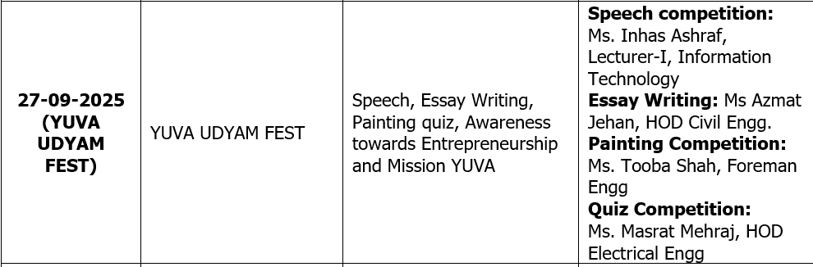

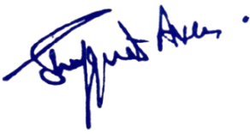

No: No: KGP/Estt/2025/1145 D Dated:22-09-2025

Principal
Kashmir Government Polytechnic College
Srinagar
Copy to the:
1.All concerned for information and compliance.

